**DBMS LAB**

**ASSIGNMENT-8**

**SNEHA SINGH**

**20198023**

**IT 5 B2**

**Q1: Create the tables described below:**

**Table Name: CLIENT_MASTER**

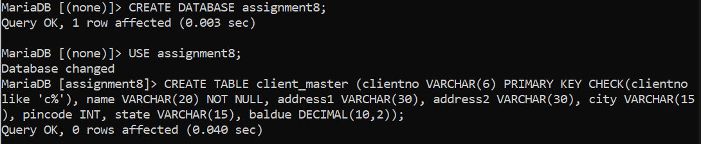

**Table Name: PRODUCT_MASTER**

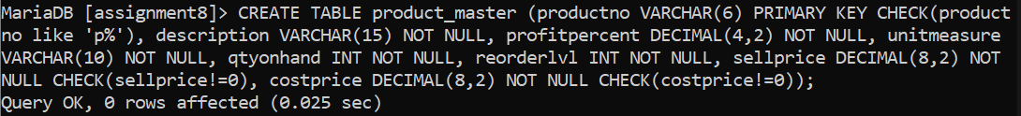

**Table Name: SALESMAN_MASTER**

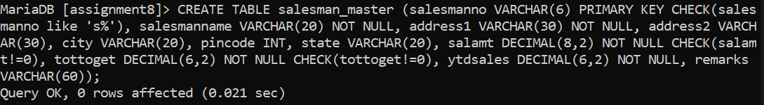

**Table Name: SALES_ORDER**

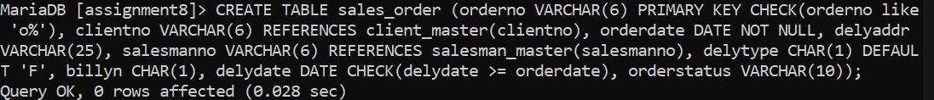

**Table Name: SALES_ORDER_DETAILS**



**2. Insert the following data into their respective tables:**

**Table Name: CLIENT_MASTER**

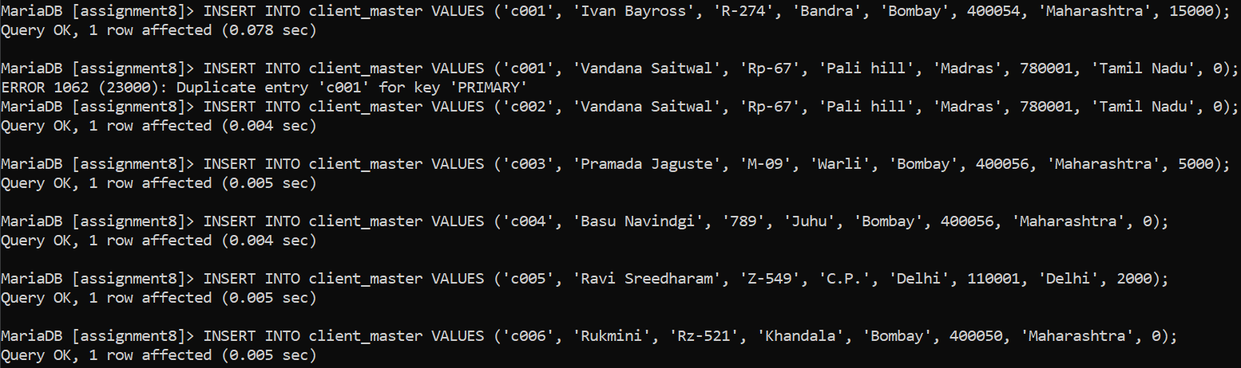

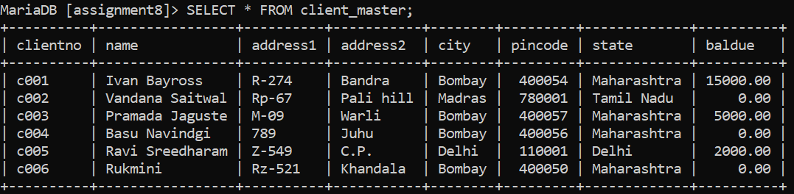

**Table Name: PRODUCT_MASTER**

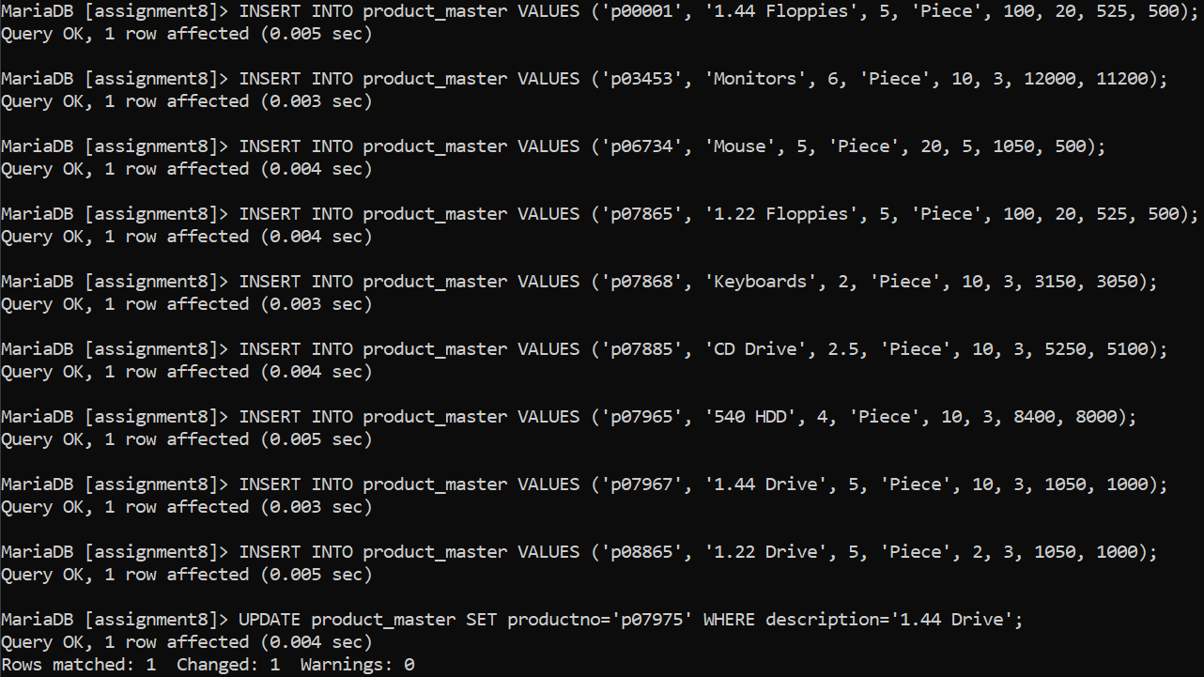

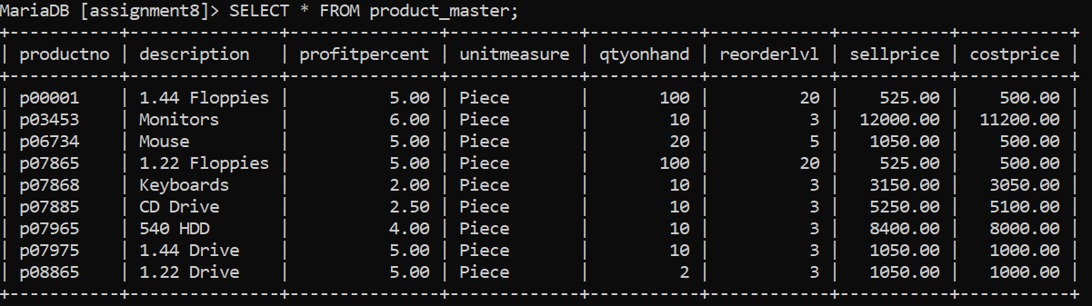

**Table Name: SALESMAN_MASTER**

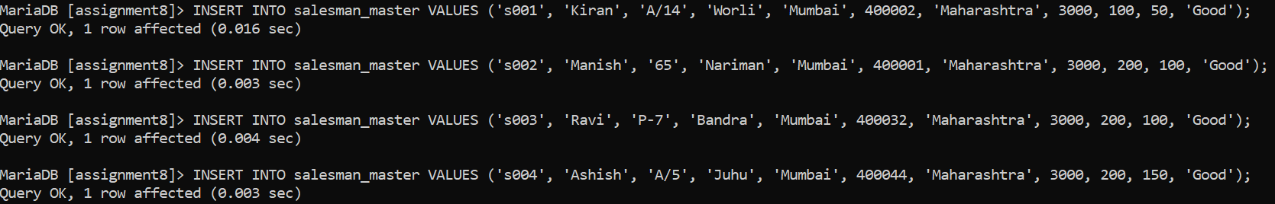

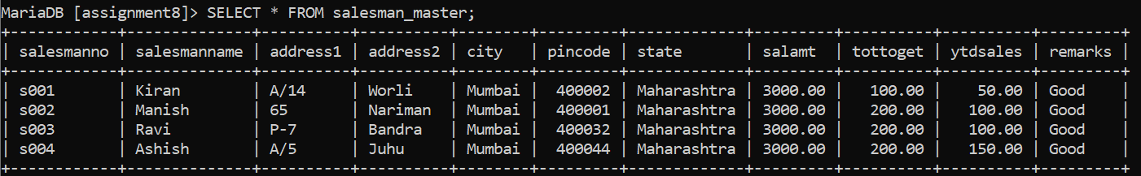

**Table Name: SALES_ORDER**

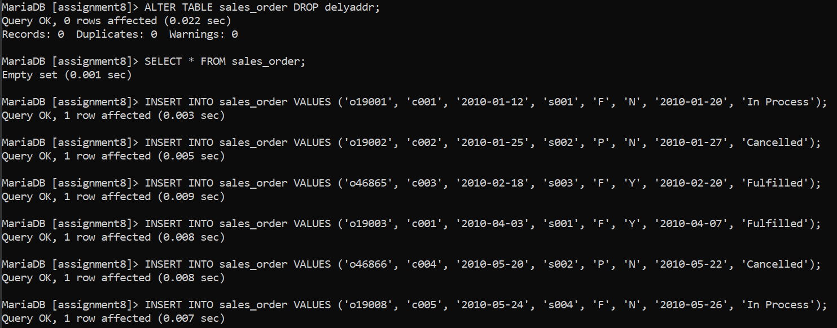

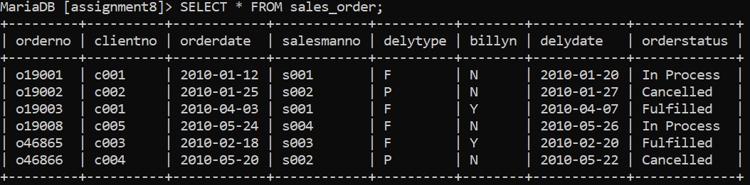

**Table Name: SALES_ORDER_DETAILS**

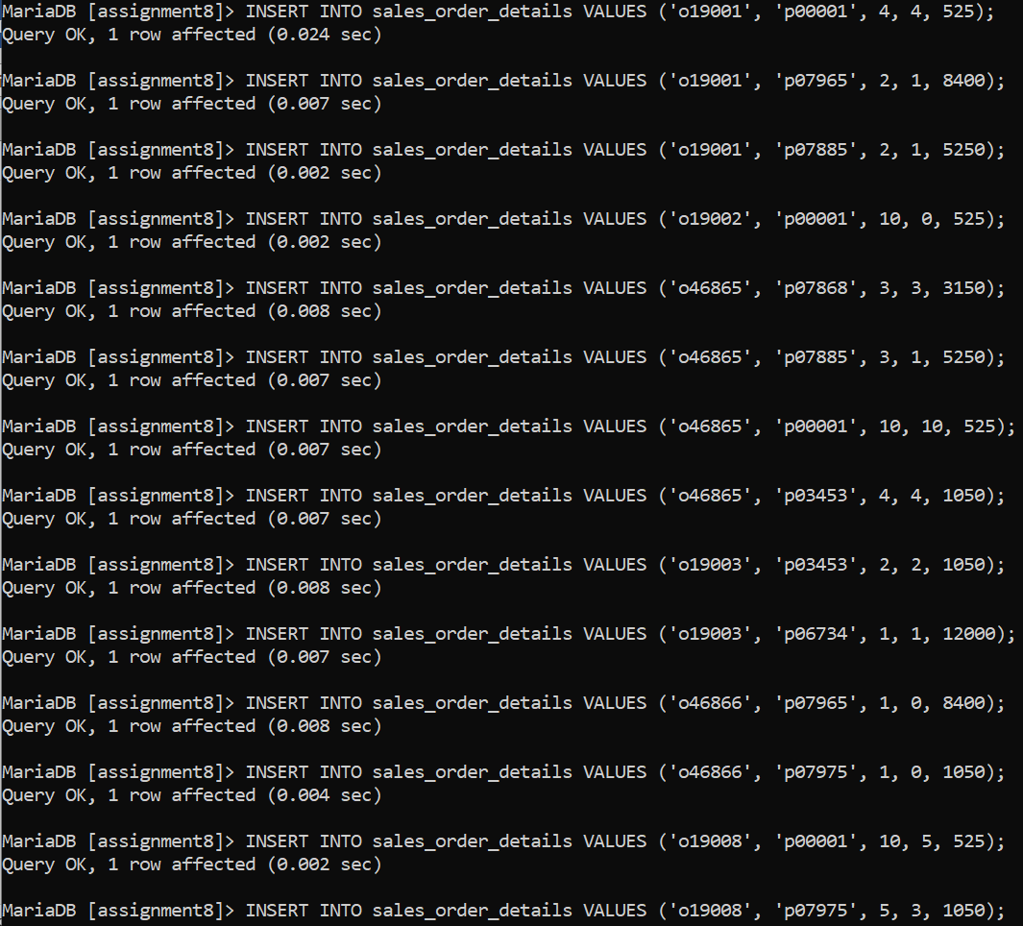

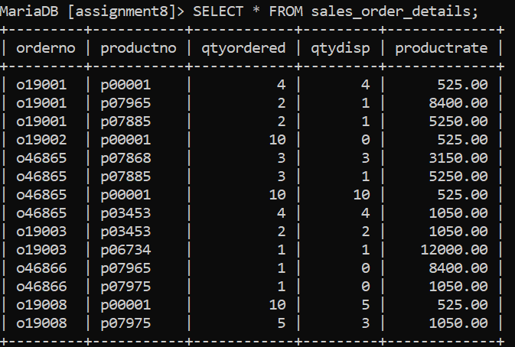

**3. Using the tables created previously generate the SQL statements for the operations mentioned below. The tables in user are as follows:**

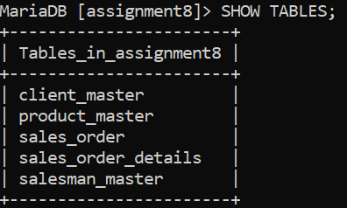

**i) Perform the following computations on table data:**

**a. List the names of all clients having ‘a’ as the second letter in their names.**

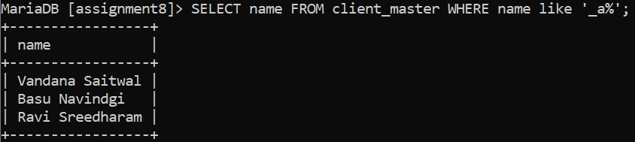

**b. List the clients who stay in a city whose First letter is ‘M’.**

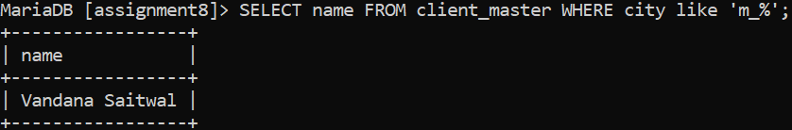

**c. List all clients who stay in ‘Bangalore’ or ‘Mangalore’**



**d. List all clients whose BalDue is greater than value 10000.**

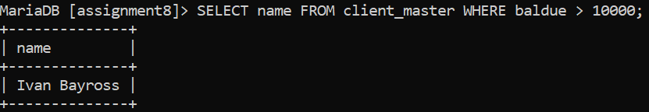

**e. List all information from the Sales_Order table for orders placed in the month of June.**



**f. List the order information for ClientNo ‘C00001’ and ‘C00002’.**

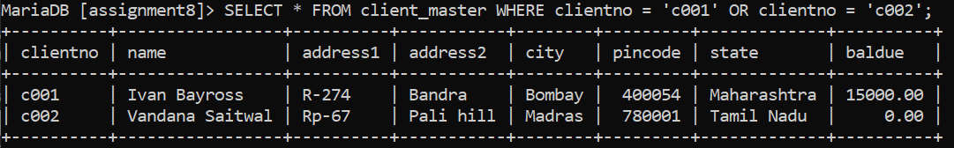

**g. List products whose selling price is greater than 500 and less than or equal to 750.**

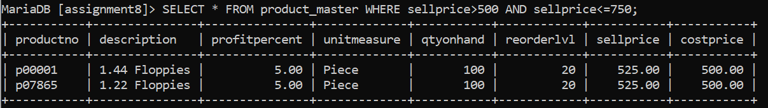

**h. List products whose selling price is more than 500. Calculate a new selling price as, original selling price*.15. Rename the new column in the output of the above query as new_price.**

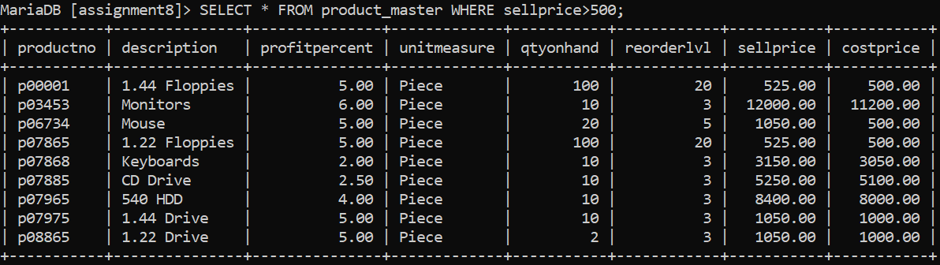

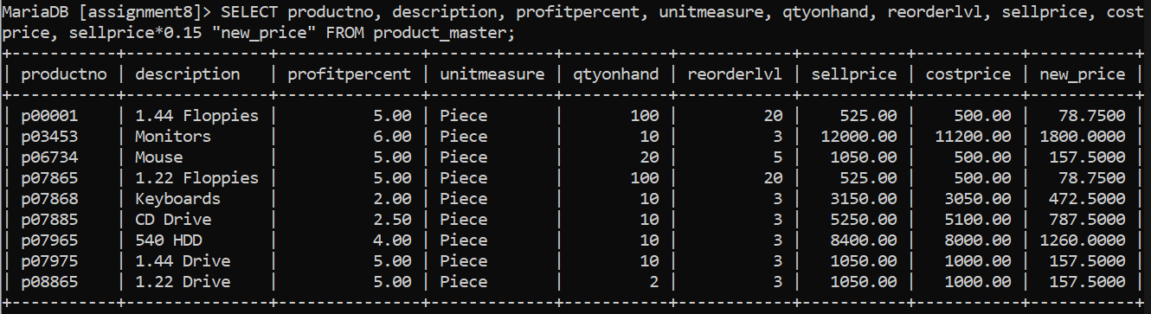

**i. List the names, city and state of clients who are not in the state of ‘Maharashtra’.**

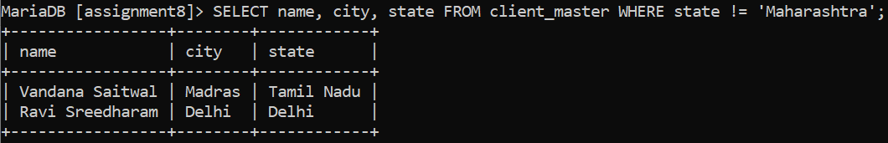

**j. Count the total Int of orders.**

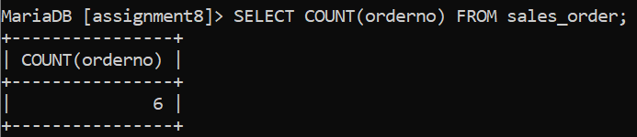

**k. Calculate the average price of all the products.**

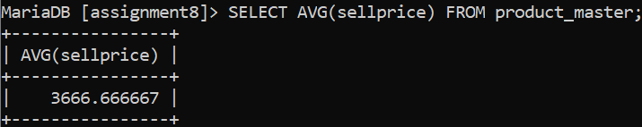

**l. Determine the maximum and minimum product prices. Rename the output as max_price and min_price respectively.**

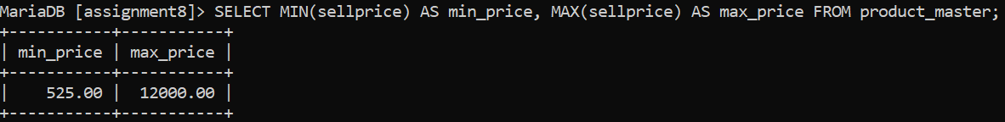

**m. Count the Int of products having price less than or equal to 500.**

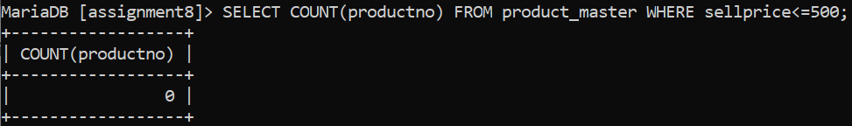

**n. List all the products whose QtyOnHand is less than recorder level.**

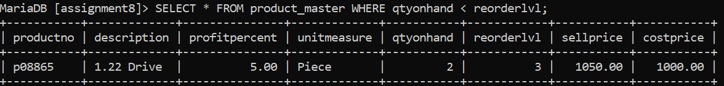

**ii) Exercise on Date Manipulation:**

**a. List the order Int and day on which clients placed their order.**

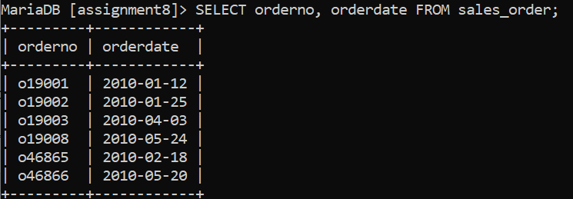

**b. List the month (in alphabets) and date when the orders must be delivered.**

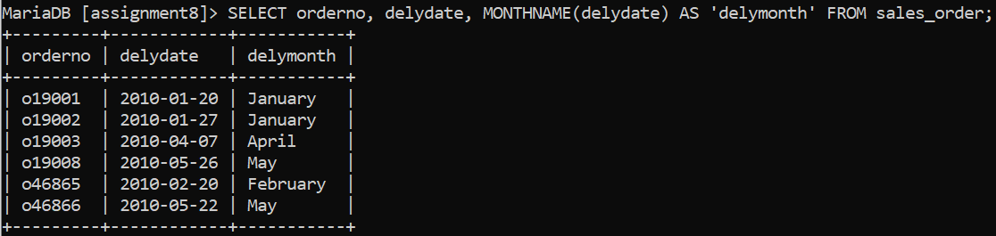

**c. List the OrderDate in the format ‘DD-Month-YY’. E.g. 12-February-02.**

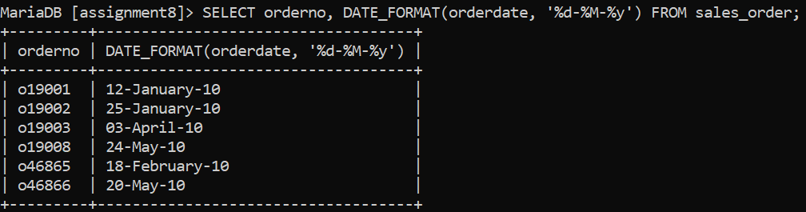

**d. List the date, 15 days after today’s date.**

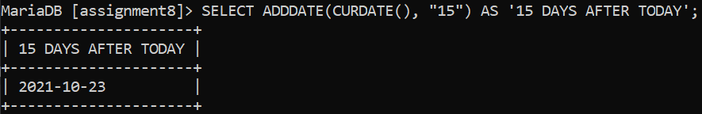

**4. Exercises on using Having and Group By Clauses:**

**a. Print the description and total qty sold for each product.**

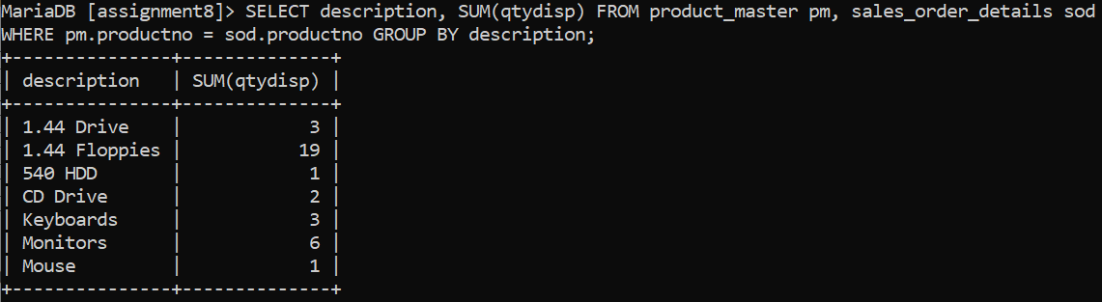

**b. Find the value of each product sold.**

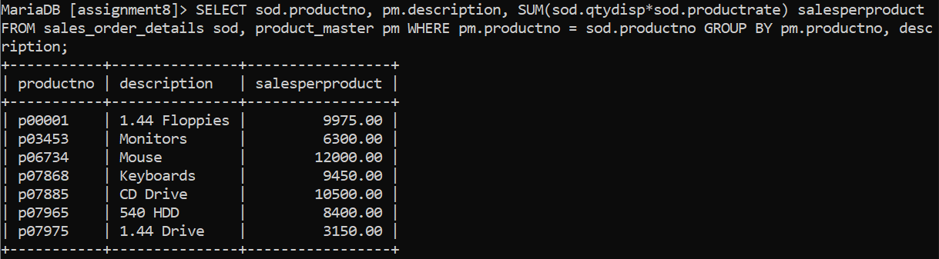

**c. Calculate the average qty sold for each client that has a maximum order value of 15000.00.**

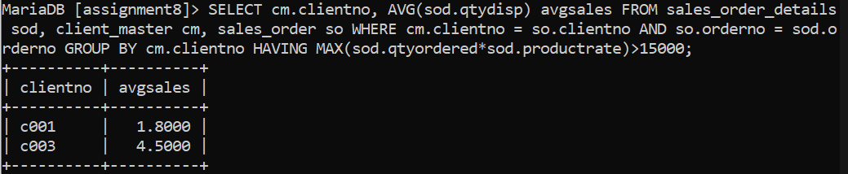

**d. Find out the total of all the billed orders for the month of June.**

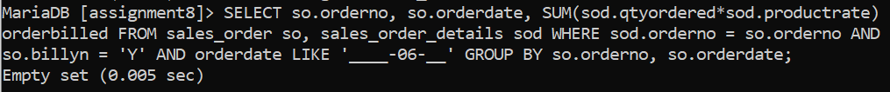

**i) Exercise on Joins and Correction:**

**a. Find out the products, which have been sold to ‘Ivan Bayross’.**

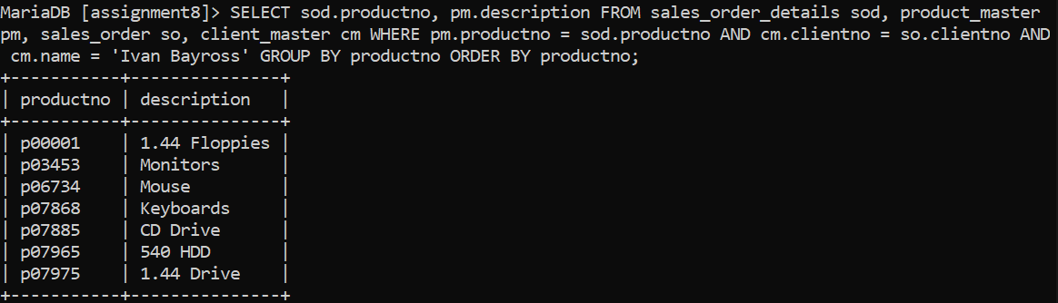

**b. Find out the products and their quantities that will have to be delivered in the current month.**

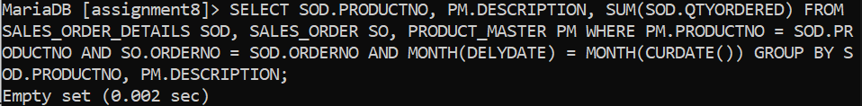

**c. List the ProductNo. and description of constantly sold (i.e., rapidly moving) products.**

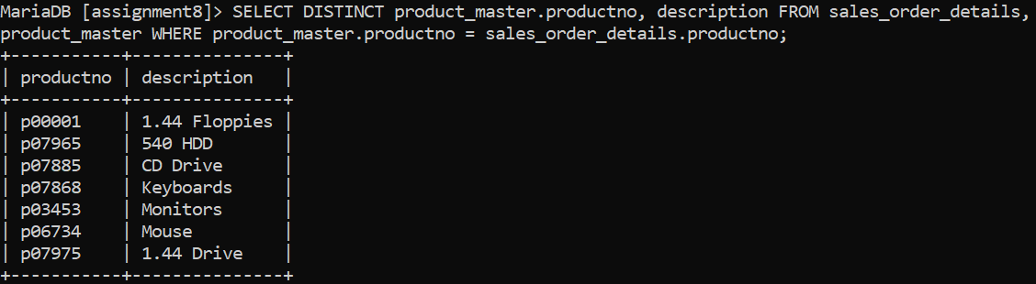

**d. Find the names of clients who have purchased ‘Trousers’.**



**e. List the products and orders from customers who have ordered less than 5 units of ‘Pull Overs’.**



**f. Find the products and their quantities for the orders placed by ‘Ivan Bayross’ and ‘Mamta Muzumdar’**

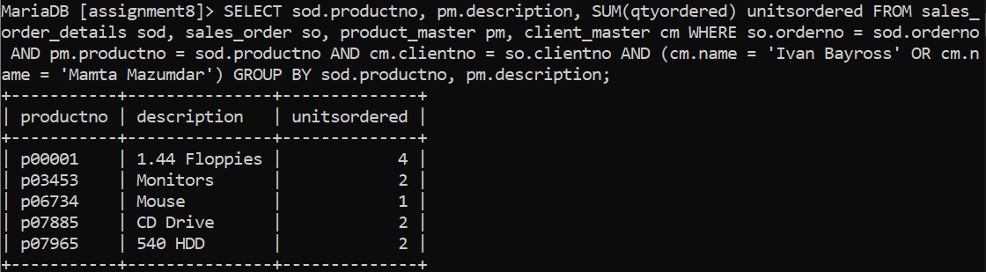

**g. Find the products and their quantities for the orders placed by ClientNo ‘C00001’ and C00002’.**

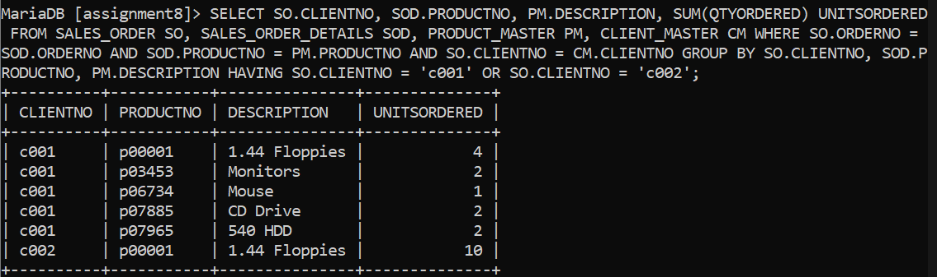

**ii) Exercise on Sub-queries:**

**a. Find the ProductNo and description of non-moving products i.e. products not being sold.**

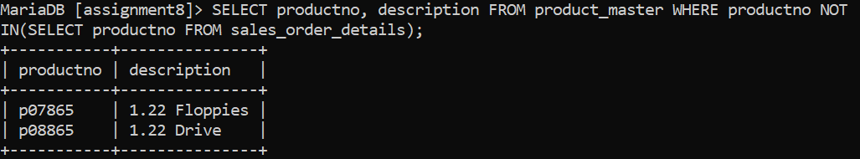

**b. List the customer Name, Address1, Address2, City and PinCode for the client who has placed order no ‘O19001’.**

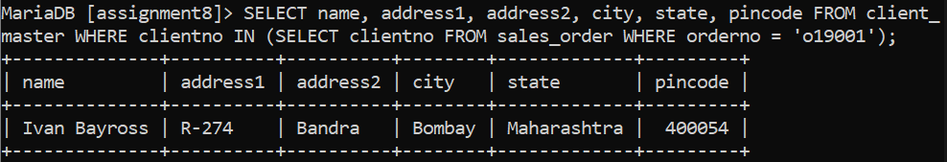

**c. List the client names that have placed orders before the month of May, 02.**

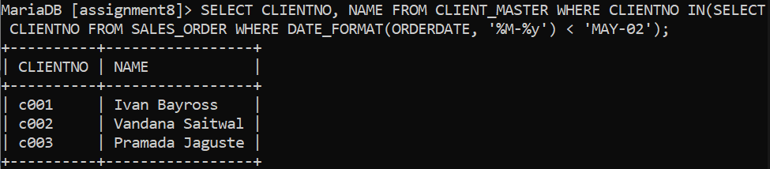

**d. List if the product ‘Lycra Top’ has been ordered by any client and print the Client_no, Name to whom it was sold.**



**e. List the names of clients who have placed orders worth Rs. 10000 or more.**

